**Compiled 3CDMAS questions v 1.04**

**Contents**

**Calculus  
Matrices  
Complex Numbers and Polar Coordinates  
Proofs  
Vectors  
Absolute Values  
Notes (not the kind of which you take 4 pages into the exam, but notes on a few of the questions. These questions are identified by an *)  
Version History  
Credits**

**Calculus**

**Canning College 2010 S2 RF 8 c**  [4 marks]

Determine, in simplified form:

$$\int_{0}^{4}{\frac{x}{\sqrt{25-x^{2}}}}dx$$

**Canning College 2010 S2 RR 12** [4 marks]

Consider the function $P=2π\sqrt{\frac{t}{5}}$

Use a calculus method to determine the error in calculating P if t is measured to be 3 ± 0.1

**Canning College 2010 S2 RR 13** [1, 3, 2, 2 marks]

An object is moving along the *x* axis such that its velocity after *t* seconds is given by

$v=2π\cos{4πt+4π\cos{2πt}}$

Given the object is initially at $x=4$, determine:

The maximum velocity of the object

The time taken for the object to return to its starting position for the first time

The distance the object travels in the first 0.1 seconds (use your calculator but indicate the method used)

The acceleration of the object at t = 2 seconds

**Edwest 2011 S2 RF 2 a i** [2 marks]

Find: $\frac{d}{dx}\int_{1}^{2x}{\frac{1-u^{2}}{\sin{u}}} du$

**Edwest 2011 S2 RF 6** [4, 2 marks]

Establish the inequalities $x\cos{x}<\sin{x}<x$ for $0<x<\frac{π}{2}$ using ideas related to the unit circle

Use the above result to establish $$\lim_{x→0}{\frac{\sin{x}}{x}}$$

**Edwest 2011 S2 RR 10** [7 marks]

Police Forensic Investigators are called late at night to investigate a murdered person in a suburban house. To get an idea of when the person died, the investigators use Newton’s Law of Cooling which states that the rate of change of the temperature of a body is proportional to the difference between its own temperature and the ambient temperature (temperature of the surroundings). The investigators note the body’s temperature when they arrived at 3:15am was 17.4°C and at 4:15am was 15.0°C. To estimate the time of death, the investigators assume the room temperature that night remained a constant 10°C and that the person’s body had a temperature of 37.0°C at the time of death. Use Newton’s Law of Cooling and the supplied information to estimate the time of death to the nearest 5 minutes.

**Hale/St Mary’s 2012 S2 RR 9** [5, 3, 4 marks]

A ladder, 2 metres long, has its base on level ground and its top resting against a vertical wall. A ring is fixed 0.5m from the base of the ladder as shown below. The ladder starts to slip down at a constant rate of 0.1m/s when it is $\sqrt{3}$ metres up the wall.

How fast (exact value) is the foot of the ladder moving away from the wall initally?

How fast is the ring moving down (vertically)?

How far is the ladder up the wall when the ring is moving with a speed of $\frac{1}{20}$ m/s ?

**Hale/St Mary’s 2012 S2 RR 16** [1, 4, 4 marks]

The diagram below shows the graph of $y=f(x)$ and the graph of its inverse function



$$y=g\left(x\right)=f^{-1}(x)$$

y = f(x)

y = g(x)

P(a, b)

gradient = m

A point P (a,b) is on the graph of $y=f(x)$.

The tangent at P has a gradient m.

State the value of $g\left(f\left(a\right)\right)$

Show that $g^{'}\left(b\right)= \frac{1}{m}$

Find the coordinates of the point of intersection of the tangent at P and the tangent at $x=b$ on the graph of $y=g(x)$ in terms of a, b and m (assume $m≠-1$)

**Penrhos/MLC 2010 S2 RF 5 b** [5 marks]

Evaluate, using the substitution $x=\sin{θ}$

$$\int_{0}^{0.5}{\frac{x}{\sqrt{1-x^{2}}}} dx$$

**Penrhos/MLC 2010 S2 RR 18** [2, 4 marks]

A weight W is attached to a rope 16 m long that passes over a pulley at point P, 6 m above the ground. The other end of the rope is attached to a truck at a point A, 1 m above the ground, as shown in the diagram.

$$A$$

$$P$$

1 m

$$W$$

6 m

$$B$$

Show that $y=\sqrt{25+x^{2}}-11$ represents  
the distance in metres the weight is above  
point B, given x metres represents the

horizontal distance from point B to the truck.

If the truck moves away at the rate of 3 m/s,

how fast is the weight rising when it is 2 m above the ground?

**Mt Lawley 2011 S2 RF 2 b**  [3 marks]

Evaluate

$$\int_{1}^{e^{2}}{\frac{{(ln{x})}^{2}}{x} dx}$$

**Mt Lawley 2011 S2 RF 5** [3, 4 marks]

A minor sector of angle $2π-θ$ is removed from a circular piece of paper of radius R. The two straight edges of the remaining major sector are pulled together to form a right circular cone, with a slant height of R.



Show that the volume of the cone is given by $V=\frac{R^{3}θ^{2}\sqrt{{4π}^{2}-θ^{2}}}{{24π}^{2}}$

Assuming the radius, R, of the circular piece of paper to be fixed, show the exact value of θ which maximises the volume of the cone is $\frac{2\sqrt{2}π}{\sqrt{3}}$

**Mt Lawley 2011 S2 RR 10** [5 marks]

When an object is at a distance u cm from a lens of focal length 20 cm, an image is created at a distance of v cm from the lens.

The variables are related by the formula $\frac{1}{20}=\frac{1}{u}+\frac{1}{v}$

An object is moving with a constant speed of 2 cm/s towards the lens.

At the instant when the image is 30cm from the lens, in what direction and with what speed is the image moving?

**Mt Lawley 2011 S2 RR 17** [2, 3, 2 marks]

The displacement $x(t)$ of a small particle undergoing simple harmonic motion is given by

$x\left(t\right)=A\cos{kt}+B\sin{kt}$, where A, B and k are positive constants.

Show that $x''\left(t\right)+ k^{2}x\left(t\right)=0$

The particle completes 2.5 cycles every second and initially has a displacement of 1.5m and a velocity of 7.5m/s

Determine the exact values of the constants A, B and k

What is the amplitude of motion, correct to the nearest millimetre?

**Penrhos 2011 S2 RF 6** [3, 1, 3 marks]

Given the curve $\sin{(xy)}+ y^{2}-\frac{4}{π}x= \frac{4}{π}$ find:

$$\frac{dy}{dx}$$

The value of x when y = 0

Using the incremental formula, find the approximate change in x when y changes from 0 to 0.1. Give your answer in exact form.

**Perth College 2010 S2 RR 12** [2, 4, 5 marks]

The diagram below shows an isosceles triangle with two sides both x cm and the included angle 2θ radians.



If the perimeter of the triangle is fixed at 100cm, prove that $\sin{θ}=\frac{50-x}{x}$

Find the exact value(s) of x and θ when the area of the triangle is a maximum.

The perimeter of the triangle is no longer fixed at 100cm

The sides with length x cm are increasing at a constant rate of 1cm per minute.

The included angle is increasing at a constant rate of 0.1 radians per minute.

Find the exact rate at which the area of the triangle is increasing when x = 10 cm and θ = $\frac{π}{6}$ radians

**Perth College 2010 S2 RR 14** [3, 2, 2 marks]

In a chemical process, the quantity of an enzyme (Q mg) is modelled by the equation

$\frac{dQ}{dt}=(200-Q)×t$ where t is time in hours

Use integration to find an expression for Q in terms of t

If the initial amount of the enzyme is 1000mg, how much remains after 3 hours?

Show clearly why the long term quantity of the enzyme is not dependent on its initial amount

**Perth College 2010 S2 RR 15** [6 marks]

Use the substitution $x=\frac{5}{2}\sin{θ}$ to evaluate exactly

$$\int_{0}^{\frac{5}{4}}{\frac{1}{\sqrt{25-4x^{2}}} dx}$$

Show clearly each step of your working.

**Perth Modern School 2013 S1 RF 7** [5 marks]

Consider the following first principles definition for derivatives

If $y=f(x)$

then

$$f'\left(x\right)=\lim_{h→0}{\frac{f\left(x+h\right)-f(x)}{h}}$$

Use this definition to show that if $f\left(x\right)=\cos{2x}$ then $f'\left(x\right)=-2\sin{2x}$

**Perth Modern School S2 2012 RF 4 b** [5 marks]

Find the equation of the tangent to the curve $y=\sqrt{x+y}$ when y = 6

**Perth Modern School S2 2012 RF 7** [2, 5 marks]

Show that $\frac{1+e^{a}}{1+e^{-a}}=e^{a}$, where a is a constant

Show that

$$\int_{-3}^{3}{\frac{e^{kx}}{1+e^{kx}}} dx=3$$

where k is a constant

**Composed Question (RF)\*** [3 marks]

Evaluate

$$\lim_{x→a}{\frac{\sin{x}-\sin{a}}{\cos{x}-\cos{a}}}$$

**Perth Modern School 2013 S1 alt. (REAP) RR 11** [4, 4 marks]

Use the substitution $u=\sqrt{x+1}$ to find

$$\int{\frac{4x}{\sqrt{x+1}}} dx$$

Use the substitution $x=2\left(1+\cos^{2}{θ}\right)$ to show that

$$\int_{2}^{3}{\sqrt{\frac{x-2}{4-x}}} dx= \frac{π}{2}-1$$

**Perth Modern School 2013 S1 alt. (REAP) RR 12** **a** [3, 2, 2 marks]

Consider the curve with parametric equations $x\left(t\right)=\frac{2}{3}t^{2}+2t$, $y\left(t\right)=\sin{2t}-t$ for $t≥0$

Show that $\frac{dy}{dx}=\frac{\cos{2t}-\frac{1}{2}}{1+t^{2}}$

Find the smallest exact value of t at which the curve has a stationary point.

Hence find the equation of the tangent to the curve at this stationary point using exact values

**Perth Modern School 2013 S1 alt. (REAP) RR 10** [2, 3, 4 marks]

Find $\frac{dy}{dx}$ if $y=\frac{1}{3}\ln{(e^{3x}+k)}$ where k is a positive real constant.

Hence find

$$\int{\frac{51}{1+13e^{-3x}}} dx$$

(Hint: Express $\frac{51}{1+13e^{-3x}}$ with positive index first)

Determine the equation of the tangent to the curve $x\ln{y}=e^{-5x}+3y-4$ at the point (0,1)

**Unidentified Exam S1 RR 16** [5, 4 marks]

Use first principles to determine the derivative of $y=\sin^{2}{x}$

Given that $\ln{y}=\sqrt{1+8e^{x}}$ prove that $\ln{y} \frac{dy}{dx}=4ye^{x}$

**Composed Question (RF)** [6 marks]

Find $\frac{d}{dx}a^{x}$ and $\int{a^{x}} dx$ where a is a positive integer.

**Matrices**

**Edwest 2011 S2 RF 3** [3, 3, 3 marks]

If $5A=1-A^{2}$ find $A^{-1}$ in terms of $mA+nI$ where m and n are scalars

Matrices A and B are both 2x2 matrices and $A=BA-B+B^{2}$

Determine A if $B=\left[\begin{matrix}1 & -1 \\ 2 & 0\end{matrix}\right]$

Determine a relationship between a and b given $\left[\begin{matrix}a & b \\ b & a\end{matrix}\right]$ is its own inverse

**Hale/St Mary’s 2012 RF 5** [1, 3, 2, 2 marks]

A line segment AB is transformed by a matrix four times to become CD as shown below.

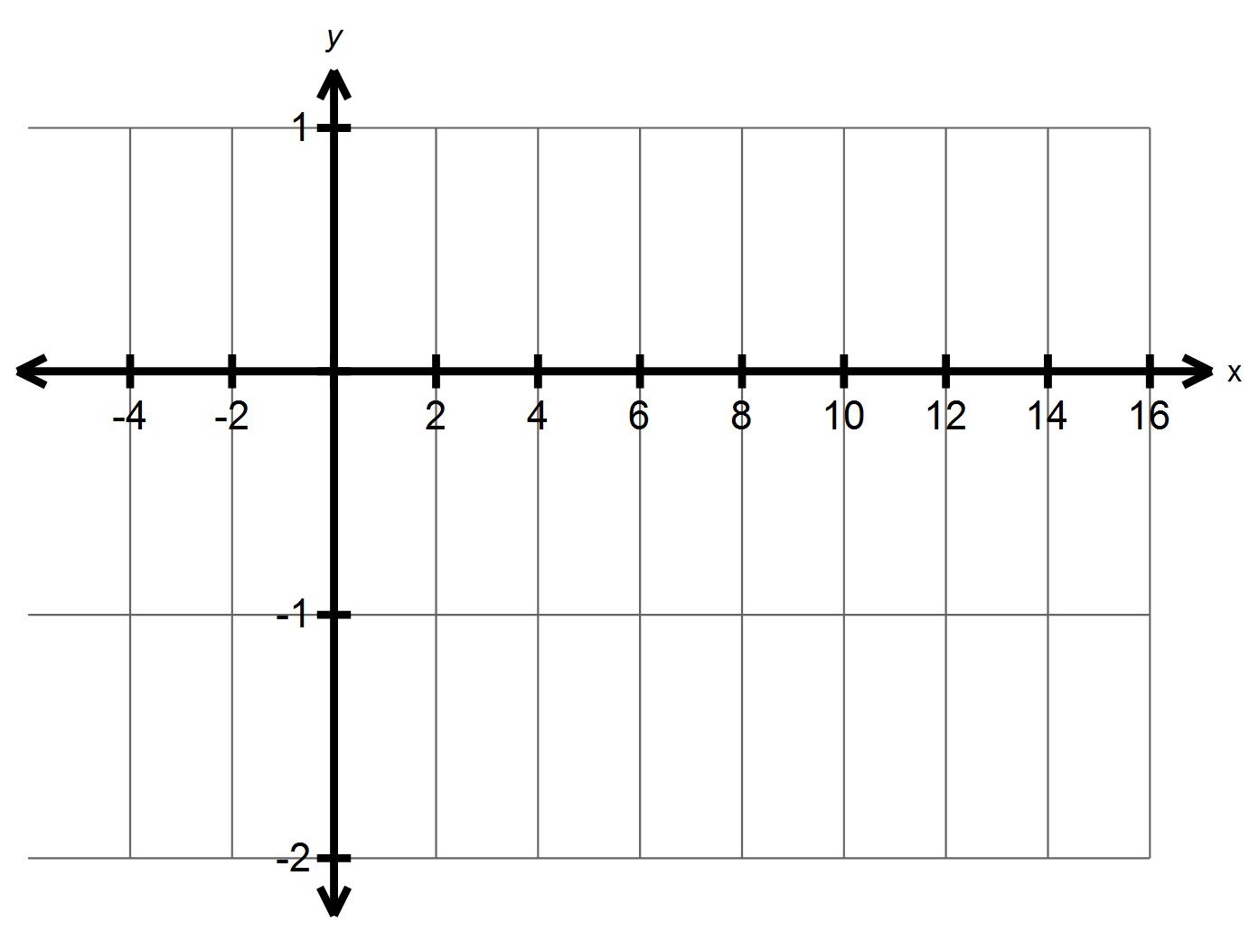

A

B

C

D

The effect of the four transformations by T can be carried out by a single transformation matrix S. State the relationship between T and S.

Determine the matrix S.

Describe the geometric effect of matrix S

Determine the matrix T

**Penrhos/MLC 2010 S2 RF 1** [5 marks]

The transformation matrix T is defined by $T=AB$, where A and B are the transformations:

A: a rotation about the origin through 210° anticlockwise

B: a reflection in the line through the origin that makes an angle of 120° with the x-axis

Determine the matrix T and describe T geometrically.

**Penrhos/MLC 2010 S2 RR 9** [1, 7 marks]

Let $A=\left(\begin{matrix}-4 & 20 & 2 \\ -3 & 15 & -3 \\ 7 & -17 & 1\end{matrix}\right)$ and $B=\left(\begin{matrix}2 & 3 & 5 \\ 1 & 1 & 1 \\ 3 & -4 & 0\end{matrix}\right)$

Determine $C=A×B$

Tickets to a concert cost $2 for children, $3 for teenagers and #5 for adults. 570 people attended the concert and the total ticket receipts were $1950. The ratio of teenagers to children attending was 3 to 4.

Use your answer to the part above to determine how many children, teenagers and adults attended the concert.

**Perth College 2011 S2 RF 6** [3, 3 marks]

Consider a $2×2$ matrix, $A=\left[\begin{matrix}3 & 1 \\ 1 & -1\end{matrix}\right]$

If $A^{2}=αA+βI$ where α and β are real numbers and I is the $2×2$ identity matrix, find αand β

Write A4 in the form $kA+cI$ where k and c are real numbers and I is the $2×2$ identity matrix

**Scotch College 2010 S2 RR 8\*** [3, 3, 4 marks]

*This entire question can be done without a calculator. Nice of them to put it in the RR though.*

*Remember you can use your Classpad to verify moves you think may or may not be allowed in part c.*

Find m and n if $mA+B=A$, where $A=\left[\begin{matrix}2 & 5 \\ -3 & 4\end{matrix}\right]$ and $B=\left[\begin{matrix}-n & -10 \\ 6 & -2n\end{matrix}\right]$

For what value(s) of k will the matrix $A=\left[\begin{matrix}k & 2 \\ 3 & k+1\end{matrix}\right]$ be singular?

If $aX^{2}+bX+cI=0$ and $Z=Y^{-1}XY$, where X, Y and Z are square, non-singular matrices, prove that $aZ^{2}+bZ+cI=0$

**Complex Numbers and Polar Coordinates**

**Edwest 2011 S2 RR 1 b** [3 marks]

On an Argand diagram, plot the locus of z defined by $\frac{π}{3} ≤arg⁡(z-2i)$

**Hale/St Mary’s 2012 S2 RR 15** [4, 4, 2 marks]

The diagram below shows the polar graphs of $r=kθ$ and $r=θ+c$ where k and c are constants and $0≤θ≤π$.

Determine the values of k and c



Points A (r,α) and B (r, β) are on the graphs of $r=kθ$ and $r=θ+c$ respectively such that they have the same r and the distance between them is $\sqrt{3} π$

Show that α satisfies $\frac{2}{3}π^{2}=α^{2}(1+\cos{\frac{α}{2})}$

Determine the value(s) of α

**Hale/St Mary’s 2012 S2 RR 18** [1, 2, 2, 3 marks]

The figure below shows a shaded circle satisfied by a complex number z

Write an inequality that must be satisfied



by z

Find the maximum exact value

of $|z-4|$

Find the minimum value (in radians) of $Arg\left(z-4\right)$

Find the maximum value (in radians) of $Arg(4-)$

**Penrhos/MLC 2010 S2 RR 11 a b** [3, 2, 3 marks]

Sketch in the complex plane the graph of $\arg\left(\frac{1}{z}\right)= \frac{3π}{4}$

Sketch the locus represented by $\left|z-2i\right|≤4$

Hence, find the exact greatest and least values of $|z-3+4i|$ given that $\left|z-2i\right|≤4$

**Penrhos 2011 S2 RR 11** [3, 3 marks]

The complex number $z=x+yi$ satisfies the inequality $|()^{2}-z^{2}|≤16$

Show that $\left|xy\right|≤4$

Hence sketch the set of all complex numbers z that satisfy the inequality $|()^{2}-z^{2}|≤16$

**Perth Modern School 2013 S1 RR 14 b** [2, 4 marks]

A set of points is defined as $\left\{z:\left|z-\left(4-3i\right)\right|=3\right\}$

Sketch the set of points on an Argand Diagram

Determine the minimum value of θ where $θ=\arg{z}$

**Perth Modern School 2010 S2 RF 7** [1, 3, 3 marks]

If $z^{2}=-4+4i$ find

$$z^{4}$$

$$z$$

Find real numbers a and b such that $\left(a+bi\right)\left(1+2i\right)=2i$

**Composed Question (RF)\*** [3 marks]

For domain $θ≥0$, find the equation of the curve below in the form $r=kθ$

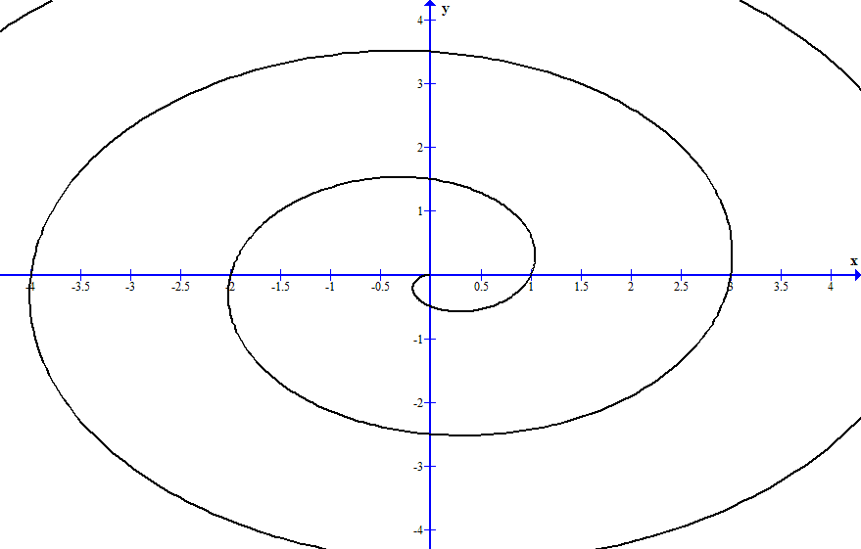

**Perth College 2011 S2 RF 7** [2, 2, 2 marks]

Let $u=a cis α$ and $w=be^{iβ}$ where a and b are real numbers and $-π≤α≤π$ and $-π≤β≤π$

State the modulus and argument of $u×\overline{w}$

Given the u and v are the two roots of the equation $z^{2}=k$, find:

The relationship between a and b

The relationship between α and β

Given that u and w are the two roots of the equation $pz^{2}+qz+r=0$ where p, q and r are non-zero real numbers, find:

The relationship between a and b

The relationship between α and β

**Scotch College 2010 S2 RF 4** [2, 3, 4 marks]

If $z=cis θ=\cos{θ}+i\sin{θ}$ and $w=cis ϕ=cos ϕ+i\sin{ϕ}$, where $θ$ and $ϕ$ are acute:

Express z-1 in terms of real and imaginary components

Show that $zw=cis \left(θ+ϕ\right)$

Find the modulus and argument of z + 1 in term of $θ$

[Hint: Draw a diagram]

**Perth Modern School 2013 S1 alt. (REAP) RR 15** [2, 3, 3 marks]

Express each of the following in polar form such that $r≥1$ and $0≤θ≤2π$

$${(1-i)}^{5}, {(-\sqrt{3}-i)}^{4}, \left(-1+i\sqrt{3}\right), {(-2+2i)}^{3}$$

**Hence**, simplify

$$\frac{{\left(1-i\right)}^{5}{(-\sqrt{3}-i)}^{4}}{(-1+i\sqrt{3}){(-2+2i)}^{3}}$$

giving your answer in Cartesian form. Your working steps must show clearly how you multiply and divide complex numbers expressed in polar form.

The complex number z is given such that $\overline{z}=\frac{-1-i}{1-\sqrt{3}i}$

Find z, $\frac{{|z|}^{2}}{z}$, and hence state a relationship between z and $\frac{{|z|}^{2}}{z}$.

**Proofs**

**Edwest 2011 S2 RR 3** [1, 2, 5 marks]

Let Matrix

Find A2, A3 and A4

State a conjecture for An, where n is a positive integer

Prove your conjecture is true using mathematical induction

**Edwest 2011 S2 RR 9** [2, 2, 2, 5, 1 marks]

Let $y=\cos{θ}+i\sin{θ}$

Show that $\frac{dy}{dθ}=iy$

Hence show, using integration, that $y=e^{iθ}$

Use this result to deduce de Moivre’s theorem

Given $\frac{\sin{6θ}}{\sin{θ}}=a \cos^{5}θ+b \cos^{3}θ+c\cos{θ}$ where $\sin{θ}≠0$, use de Moivre’s theorem with n = 6 to find the values of the constants a, b and c

Hence deduce the value of $$\lim_{θ→0}{\frac{\sin{6θ}}{\sin{θ}}}$$

**Hale/St Mary’s 2012 RF 3\*** [3, 4 marks]

Prove the following result:

$$\lim_{x→0}{\frac{1-\cos{x}}{x}=0}$$

Evaluate the following limit:

$$\lim_{x→π}{\frac{\sin{\frac{1}{2}(π-x)}}{x-π}}$$

**Hale/St Mary’s 2012 S2 RF 7** [6 marks]

Prove by contradiction that for any two integers a and b, $a^{2}-4b≠2$

**Hale/St Mary’s 2012 S2 RR 13\*** [7 marks]

Prove by mathematical induction that, if n is a positive integer,

$$n∙1+\left(n-1\right)∙2+\left(n-2\right)∙3+…+2∙\left(n-1\right)+1∙n=\frac{1}{6}n\left(n+1\right)(n+2)$$

**Hale/St Mary’s 2012 S2 RR 17** [2, 5, 3 marks]

Evaluate $\int{\frac{\tan^{n}x}{\cos^{2}x} dx}$ in terms of n, where n = 0, 1, 2, ...

If $$F\left(n\right)=\int_{0}^{\frac{π}{4}}{\tan^{n}x dx}$$

where n = 0, 1, 2, ...

show that $F\left(n+2\right)=\frac{1}{n+1}-F(n)$

Using the result from above, evaluate $F(4)$. Show working.

**Composed Question (RF)\*** [5 marks]

Prove by contradiction that there are in infinite number of primes.

**Penrhos/MLC 2010 S2 RF 7** [3 marks]

Show that $\tan{θ}+ \frac{\cos{θ}}{\sin{θ}}=\frac{2}{\sin{2θ}}$

**Penrhos/MLC 2010 S2 RR 15** [3, 3 marks]

Use de Moivre’s Theorem to show that $\cos{nθ}=\frac{1}{2}(z^{n}+z^{-n})$ and $\sin{nθ}=\frac{1}{2}(z^{n}-z^{-n})$, where $z=\cos{θ}+i\sin{θ}$

Use the part of the question above to prove the identity, $\sin{3θ}\cos{2θ}=\frac{1}{2}(\sin{5θ}+\sin{θ})$

**Penrhos/MLC 2010 S2 RR 16** [5 marks]

Use mathematical induction to show that $n!>2^{n}$ for all positive integers $n≥4$

Note: $n!=1×2×3×… ×n$

**Mt Lawley 2011 S2 RF 4** [5, 3 marks]

Consider the identity $2i\sin{nθ}=z^{n}-\frac{1}{z^{n}}$ where $z=cis nθ$

By initially letting n=1, show how to use the identity to prove that

$$\sin^{3}θ=\frac{3\sin{θ}-\sin{3θ}}{4}$$

Hence evaluate

$$\int_{0}^{π}{9\sin{x}-12\sin^{3}x dx}$$

**Penrhos 2011 S2 RF 5** [4 marks]

Prove ${(1-i\sqrt{3})}^{n}+{(1+i\sqrt{3})}^{n}= 2^{n+1}\cos{\frac{πn}{3}}$ where n = 1, 2, 3, ...

**Penrhos 2011 S2 RR 9** [4 marks]

Use proof by exhaustion to prove that 127 is a prime number

**Perth Modern School 2010 S2 RR 17** [6 (or 7) marks]

Given the identity $2\cos{A}\sin{B}=\sin{(A+B)}-\sin{(A-B)}$, prove by induction that for integers $n≥1$

$$\cos{θ}+\cos{3θ}+\cos{5θ}+…+\cos\left(2n-1\right)θ=\frac{\sin{2nθ}}{2\sin{θ}}$$

(note: do this question first using the identity, and when you’ve got that right, do this question without the identity. It’s possible, but challenging)

**O. T. Lee Textbook, 23 - Methods of Proof, 7** [5, 5, 6 marks]

Use mathematical induction to prove each of the following for integer $n≥1$

$7^{n}+2$ is divisible by 3

$8^{n}+6$ is divisible by 14

$3^{2n}-1$ is divisible by 8

**Perth Modern School 2013 S1 alt. (REAP) RR 16** [2, 1, 4 marks]

Use your CAS calculator to find the x-coordinate of the stationary point of each of the functions and complete the table below.

|  |  |  |  |  |
| --- | --- | --- | --- | --- |
| Function | $$y=\frac{1}{x}e^{2x}$$ | $$y=\frac{1}{x^{2}}e^{2x}$$ | $$y=\frac{1}{x^{3}}e^{2x}$$ | $$y=\frac{1}{x^{4}}e^{2x}$$ |
| x-coordinate of stationary point |  |  |  |  |

Make a conjecture about the x-coordinate of the stationary point of the function

$$y=\frac{1}{x^{m}}e^{2x}$$

where m is a positive integer

Prove the conjecture in the above part.

**Vectors**

**Edwest 2011 S2 RR 8**  [2, 2, 4 marks]

Show that the line L whose vector equation is $r=\left(\begin{matrix}-3 \\ \begin{matrix}-1 \\ 6\end{matrix}\end{matrix}\right)+λ\left(\begin{matrix}1 \\ \begin{matrix}-5 \\ 1\end{matrix}\end{matrix}\right)$ is parallel to the plane Π1 whose vector equation is $r.\left(\begin{matrix}1 \\ 1 \\ 4\end{matrix}\right)=12$

Find the equation of the plane Π2 that contains the line L and is parallel to Π1

Find the distance of Π1 and Π2 from the origin and hence, or otherwise, determine the distance between the planes

**Hale/St Mary’s 2012 RF 4** [5, 3, 3 marks]

The points P and Q have position vectors given by <1, 2, -4> and <3, -1, 2> respectively. The line joining PQ cuts the x-z plane at R

Find the position vector of the point R

Find the ratio at which the point R divides PQ

Find the vector equation of the plane that passes through R and is perpendicular to PQ

**Hale/St Mary’s 2012 S2 RR 11** [2, 2, 3 marks]

In the figure below, OABC is a trapezium with AB parallel to OC and 2AB = OC. The diagonals intersect at P.

P

O

A

B

C



Let **OA** = **a** and **OC** = **c**

Express **AC** and **OB** in terms of **a** and **c**

Let **AP** = λ**AC**

Express **OP** in terms of λ, **a** and **c**

Determine the value of λ

**Composed Question (RR)\*** [5 marks]

Determine the vector equation of the line which is the intersection of the planes $r.\left(\begin{matrix}1 \\ 2 \\ 3\end{matrix}\right)=4$ and $r.\left(\begin{matrix}5 \\ 6 \\ 7\end{matrix}\right)=8$

**Penrhos/MLC 2010 S2 RR 17** [6, 4 marks]

A rocket ship leaves space station A which is located at $\left(\begin{matrix}-20 \\ 40 \\ 20\end{matrix}\right)$ km at 9 am with a constant velocity of km h-1. It is supposed to reach the neighbouring space station B, which is located at $\left(\begin{matrix}80 \\ 160 \\ 2020\end{matrix}\right)$ km.

Determine whether or not this rocket ship reaches space station B. If not, find the closest distance between the rocket ship and space station B and when this occurs to the nearest minute.

A second rocket ship is also launched from space station B at 9 am with constant velocity and is aimed to collide with the first rocket at exactly 1 pm. Determine the velocity of the second rocket ship that will ensure collision takes place at the required time.

**Perth College 2010 S2 RF 5** [3, 4 marks]

The line L has the equation $r= <4, 3, -1>+ λ<1, 2, -2>$

The plane Π has the equation $r . <-1, 1, 1> =2$

Find the position vector of the point of intersection between L and Π

The acute angle between L and Π is θ. Find sin θ.

**Composed Question (RR)\*** [3 marks]

Determine a unit vector perpendicular to the plane containing the lines

$a= <-1, 2, 3> + λ<3, 2, 1>$ and $b= <1, 3, 5> + μ<2, 1, 2>$

**WACE 2012 RF 6\*** [2, 2, 3 marks]

Describe geometrically the set of points $r=(x, y, z)$ that satisfy each of the following vector equations in which **a** denotes a non-zero constant vector

$$\left|r-a\right|=3$$

$$\left(r-a\right)∙a=0$$

$$\left(r-a\right)∙r=0$$

**St Mary’s 2011 S2 RR 15\*** [1, 2, 3, 4 marks]

A co-ordinate system is defined showing the positive co-ordinate axes with O being the origin. Two part time rock-climbers Des Duller and Kev Krudder are each attached to two straight wires that allow them to slide down within a wide canyon.

At exactly 0930 hours, Des is at a position of <-250, 350, 700> metres and is sliding down his wire with velocity <2.5, -1, -1> metres per second. Meanwhile, Kev is stationary at a position <500, -200, 800> metres admiring the view. At exactly 0935 hours, Kev begins to slide down his wire at a velocity of <-0.5, 1, -1.5> metres per second.

**z**

**x**

**y**

What is Kev’s speed (correct to the nearest 0.01 m/sec) as he slides down his wire?

At what angle to the horizontal plane does Kev slide down, correct to the nearest degree?

It is known that Des and Kev do not collide. Determine the distance of their closest approach (correct to the nearest metre) and when this occurs (correct to the nearest second)

If Kev was able to select both the speed and time at which he commenced sliding down his wire, determine the distance, correct to the nearest metre, he would be able to get closest to Des?

Explain showing your method.

**Unidentified Exam S1 RR 9** [2, 2, 6 marks]

Find the equation of the plane passing through <1, -1, 3> and parallel to the plane

$$r∙\left(3i+j+k\right)=7$$

Find the obtuse angle between the two planes define by

Plane I: $r∙\left(i+j\right)=1$

Plane II: $r∙\left(2i+j-2k\right)=2$

Find the shortest distance from the point P(2, -3, 4) to the plane $r∙\left(i+2j+3k\right)=13$

**Absolute Values**

**Penrhos/MLC 2010 S2 RF 2** [7 marks]

Use an algebraic method to solve $3|x-2|>|2x+1|$

**Perth Modern School 2013 Test 5 (RF), 1** [3, 2 marks]

The graphs of $f\left(x\right)=\left|2x-1\right|$ and $g\left(x\right)=\left|x+2\right|$ are shown below.

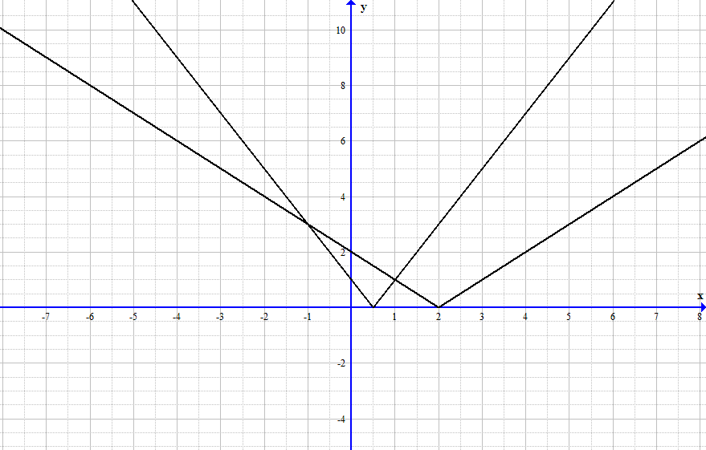

On the same cartesian plane, draw a neat sketch of $y=f\left(x\right)-g\left(x\right)$

Hence solve $f\left(x\right)-g\left(x\right)=3$

**Notes**

**Calculus**The composed question, evaluating the limit as x approaches a, is made possible by L’Hopital’s rule, which basically says that if initial substitution the variable into the limit (i.e. replacing the a’s with x) results in 0/0 or infinity/infinity, then

$$\lim_{x→a}{\frac{f(x)}{g(x)}}=\lim_{x→a}{\frac{f'(x)}{g'(x)}}$$

So to do this question, you differentiate the top and bottom with respect to x, and then substituting a into the limit, and your answer should be $-\frac{1}{\tan{a}}$ or $-\cot{a}$. L’Hopital’s rule is not in the course, but can still be used. But remember that this only works if you initially get 0/0 or infinity/infinity.

**Matrices**

Scotch College 2010 S2 RR 8 a and b should be easy if you have a good understanding of matrices. Part c however, is more tricky, as it tests your ability and manipulate equations with matrices and your understand of matrix algebra. To do this question, you must do a proof by deduction similar to ones for trig identities, with $LHS=aZ^{2}+bZ+cI$ and then substituting Z into the equation and going from there.

This question cannot be done by manipulating the second equation into $X=Z$ because $Z{(XY)}^{-1}$ does not expand to $ZX^{-1}Y^{-1}$ unfortunately, though surprisingly this incorrect manipulation still ends with the correct result.

**Complex Numbers and Polar Coordinates**  
The composed question in this section, finding the equation of a polar graph, was made with the fact in mind that with r = kθ, k can be negative, in which case the graph will come out of the origin in the 3rd quadrant. Otherwise, an easy question.  
 **Proofs**  
Hale/St Mary’s 2012 RF 3 comprises of two limits that both, when substituting $x=0$ will yield $\frac{0}{0}$, so L’Hopital’s rule can be applied to both of these. However, the first of these asks to prove the limit, so using L’Hopital’s rule may not be the safest way of doing this question. Unlike the proof for $\frac{\sin{x}}{x}$, this proof is only algebraic, as long as

$$\lim_{x→0}{\frac{\sin{x}}{x}}=0$$

is already established. This proof is straight out of the 3C Sadler book.

$$\lim_{x→0}{\frac{1-\cos{x}}{x}}$$

$$=\lim_{x→0}\left(\frac{1-\cos{x}}{x}×\frac{1+\cos{x}}{1+\cos{x}}\right)$$

$$=\lim_{x→0}{\frac{1-\cos^{2}{x}}{x(1+\cos{x)}}}$$

$$=\lim_{x→0}{\frac{\sin^{2}{x}}{x(1+\cos{x)}}}$$

$$=\lim_{x→0}{\frac{\sin{x}}{x}} ×\lim_{x→0}{\frac{\sin{x}}{1+\cos{x}}}$$

$$=0×1$$

$$=0$$

This proof also uses

$$\lim_{x→a}{(f\left(x\right)∙g\left(x\right))}=\lim_{x→a}{f(x)}∙\lim_{x→a}{g(x)}$$

which may be useful to remember.

The second limit says to evaluate, so after checking that it evaluates to $\frac{0}{0}$ you can hop on ahead.

-

Included in this set is the proof that there are infinitely many primes. This is a proof by Euclid mentioned explicitly in the syllabus under 3DMAS point 5.7. The solution is as follows, from a word document given to us on proofs:

  
In case you don’t follow, you start by assuming there is a finite number of prime numbers, and you multiply all of these prime numbers together, which I will call y. The number y + 1 must have a prime factor ‘p’, as all natural numbers do, and this prime factor p must be included in the set of prime numbers. By this logic, p is a factor of y and also y + 1, so p is a factor of (y-1)-y, which equals one, so p is a factor of 1, <insert ending crap> Q.E.D.

-

The Hale/St Mary’s RR proof is beyond my comprehension. Unfortunately I am not a maths god. I would recommend ignoring this question. It’s only in here because it is most definitely difficult. In case you do want to see the solutions, you can look at the exam solutions yourself in the Hale/St Mary’s 2012 solutions, or below is a solution by Conway Li.

$$P\left(n\right)=\sum_{i=1}^{n}{i\left(n+1-i\right)}=\frac{1}{6}n\left(n+1\right)\left(n+2\right), nϵN$$

$$LHS P\left(1\right)=\sum_{i=1}^{1}{i\left(n+1-i\right)}=1∙1=\frac{1}{6}∙1∙2∙3=\frac{1}{6}∙1∙\left(1+1\right)∙\left(1+2\right)=RHS P\left(1\right)$$

Hence P(1) is true

Assume P(k) true for some K, i.e.

$$\sum_{i=1}^{k}{i\left(k+1-i\right)}=\frac{1}{6}k\left(k+1\right)\left(k+2\right)$$

Then

$$LHS P\left(k+1\right)= \sum_{i=1}^{k+1}{i\left(\left(k+1\right)+1-i\right)}$$

$$=\sum_{i=1}^{k}{i\left(k+1-i\right)+i}+\left(k+1\right)\left(\left(k+1\right)+1-\left(k+1\right)\right)$$

$$=\sum_{i=1}^{k}{i(k+1-i)}+\sum_{i=1}^{k}{i}+k+1$$

$$=\frac{1}{6}k\left(k+1\right)\left(k+2\right)+\frac{k\left(k+1\right)}{2}+k+1$$

$$=\frac{1}{6}\left(k+1\right)\left(k\left(k+2\right)+3k+6\right)$$

$$=\frac{1}{6}\left(k+1\right)\left(k\left(k+2\right)+3\left(k+2\right)\right)$$

$$=\frac{1}{6}\left(k+1\right)\left(\left(k+1\right)+1\right)\left(\left(k+1\right)+2\right)$$

$$=RHS P\left(k+1\right)$$

<ending crap> Q.E.D.

**Vectors**

With the composed question, the line of intersection between two planes, the answer should be $\left[\begin{matrix}-2 \\ 3 \\ 0\end{matrix}\right]+λ\left[\begin{matrix}1 \\ -2 \\ 1\end{matrix}\right]$ or similar. The position vector can be any point on the line, and any scalar multiple of the direction will do. If you get a direction like <1.5, -3, 1.5>, recognise that you can simplify it by dividing it by 1.5 to get the answer above. Firstly, find two points that lie on both planes, and then work out the equation of the line from there. Letting r = <a, b, c>, substitute into both plane equations, and then let either a, b or c = 0, for both equations (the same variable must be 0). For example, let b=0. We get a + 3c = 4 and 5a + 7c = 8, which we solve to get a = -0.5 and c = 1.5, which along with b = 0 tells us that the point <-0.5, 0, 1.5> lies on both planes. Repeat for a different variable = 0, to find your second point, and it’s easy from there. Or instead of substituting 0 into variables first, you can substitute <a, b, c> into each plane equation and solve simultaneously for two of the variables. For example, solving for a and b will yield a = c – 2 and b = -2c + 3, which you can substitute 0 for c, find your other variables and there’s one point. Go back and solve switch which variable you’re not solving for, substitute 0 in, and you have your two points.

The other composed question in this section, finding the unit vector perpendicular to two lines, is a very easy question if you use the cross product. Although not in the course, it is allowed. The cross product of two vectors produces a vector perpendicular to both input vectors, and so to do this question, you cross product the directions of both given lines, and then find the unit vector of the result.

**WACE 2012 RF 6**

Describe geometrically the set of points $r=<x,y,z>$ that satisfy each of the following vector equations in which $a$ denotes a non-zero constant vector.

$\left|r-a\right|=3$

$\left|r-a\right|⋅a=0$

$\left|r-a\right|⋅r=0$

Part (a) includes the set of points which lie a distance of 3 units from $a$, which is shaped as hollow sphere with center at $a$ and radius 3 units.

Part (b) can be expanded to give $r⋅a=a⋅a$ which is the equation of a plane with normal vector $a$ and passing through the point with position vector $a$.

Part (c) includes the set of points such that their position relative to $a$ is perpendicular to their position relative to the origin. This is similar to a semicircle, “angles in a semicircle are 90 degrees”.

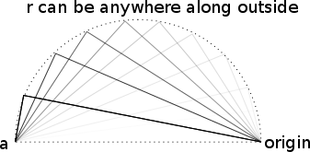

However remember that this is 3D, so any semicircle that includes the line between $a$ and the origin will have points that follow the equation. Hence it is a sphere, with one end of the sphere at the origin, and the other end at $a$.

**St Mary’s 2011 S2 RR 15**

The first 3 parts of this question are quite straightforward, with a small complication that Kev and Des do not start moving at the same time.

Perhaps the most difficult part of this question is the last part. Although it sounds like a complicated problem, because Kev is able to select both speed and starting time, he is able to be at any given point on the line at whatever time he desires. Hence, this problem is simply a ‘distance between skew lines’ question. Realising this quickly will save a lot of hassle.

A method to do this is shown in the O T Lee Revision Series book, in chapter 03, Three Dimensional Vectors III, in some of the questions. Another method is outlined below.

To find the shortest distance between the two lines

$$L_{1} : \vec{r}\left(λ\right)= \left[\begin{matrix}x_{1} \\ y_{1} \\ z_{1}\end{matrix}\right]+λ\left[\begin{matrix}v_{x1} \\ v_{y1} \\ v_{z1}\end{matrix}\right]L_{2} :\vec{r}\left(μ\right)= \left[\begin{matrix}x_{2} \\ y_{2} \\ z_{2}\end{matrix}\right]+μ\left[\begin{matrix}v_{x2} \\ v_{y2} \\ v_{z2}\end{matrix}\right]$$

Let A and B be two points on the lines L1 and L2 such that

$$\vec{r_{A}}\left(λ\right)= \left[\begin{matrix}x_{1} \\ y_{1} \\ z_{1}\end{matrix}\right]+λ\left[\begin{matrix}v_{x1} \\ v_{y1} \\ v_{z1}\end{matrix}\right]\vec{r_{B}}\left(μ\right)= \left[\begin{matrix}x_{2} \\ y_{2} \\ z_{2}\end{matrix}\right]+μ\left[\begin{matrix}v_{x2} \\ v_{y2} \\ v_{z2}\end{matrix}\right]$$

When A and B are closest, the following simultaneous equations are satisfied (where $\frac{δ}{δλ}$ and $\frac{δ}{δμ}$ denote partial differentiation):

$${{}_{A}^{}{\vec{r}}}_{B }∙ \frac{δ}{δλ}\left({{}_{A}^{}{\vec{r}}}_{B }\right)=0$$

$${{}_{A}^{}{\vec{r}}}_{B }∙ \frac{δ}{δμ}\left({{}_{A}^{}{\vec{r}}}_{B }\right)=0$$

By solving simultaneously the above equations, a value for λ and μ is obtained, allowing the magnitude of AB at the optimum values of λ and μ to be found.

**Version History**

* 1. – Version History added. WACE 2012 RF 6 added to Vectors and relevant notes added. RR and RF added to titles of Composed Questions.
  2. – MtLawley 2011 S2 RR 17 from Calculus section, error fixed. Originally read xn instead of x”. Mt Lawley 2011 S2 RR 10 retyped. Originally missing information. Questions 4 (RF) and 8 (RR) from the Scotch College 2010 exam were added to ‘Complex Numbers and Polar Coordinates’ and ‘Matrices’ respectively, and notes for 8.
  3. – ‘dx’ added to some integrals. St Mary’s 2011 S2 RR 15 added to ‘Vectors’ along with notes. Credits added.
  4. – Corrections:

|  |  |
| --- | --- |
| Matrices | Penrhos/MLC 2010 S2 RR 9 |
| Complex Numbers and Polar Coordinates | Perth Modern School 2013 S1 RR 14 b  Scotch College 2010 S2 RF 4 |
| Proofs | Penrhos 2011 S2 RF 5  Perth Modern School 2010 S2 RR 17 |
| Vectors | Perth College 2010 S2 RF 5  Composed Question (perpendicular unit vector question)  St Mary’s 2011 S2 RR 15 (diagram added) |

Additions:

|  |  |
| --- | --- |
| Calculus | Perth Modern School 2013 S1 alt. (REAP) RR 10  Perth Modern School 2013 S1 alt. (REAP) RR 11  Perth Modern School 2013 S1 alt. (REAP) RR 12 a  Unidentified Exam S1 RR 16  Composed Question (RF) |
| Complex Numbers and Polar Coordinates | Perth Modern School 2013 S1 alt. (REAP) RR 15 |
| Proofs | Perth Modern School 2013 S1 alt. (REAP) RR 16 |
| Vectors | Unidentified Exam S1 RR 9 |

Notes for Hale/St Mary’s 2012 RF 3 from Proofs added.

**Credits**

The questions in this document are from their source, as above each question, and credit for them is to their respective exam’s writer. Composed questions have been made by Ja-Jet Loh and James Houlahan (as far as I know :P). Notes written by Ja-Jet Loh, James Houlahan, and contributions by Conway Li.